**SD-WAN Programmability Lab guide – Postman**

Before you begin, ensure you have your Anyconnect connected to your assigned dCloud instance. See below for Anyconnect access details for your dCloud assigned instance:

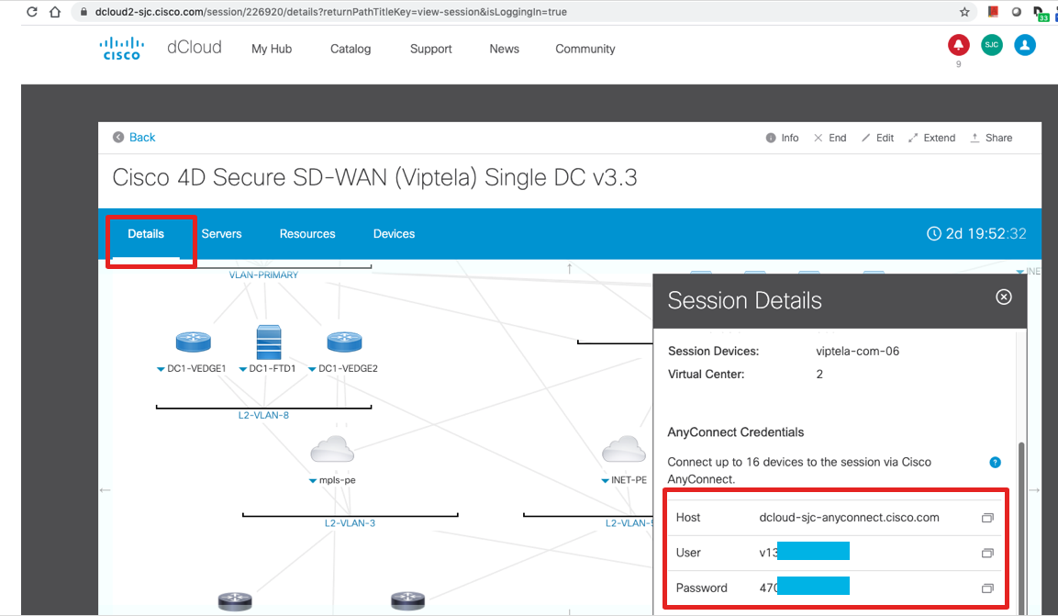

**Step 1: Install postman**

Download postman from the below url, it’s a free software

<https://postman.com/donwloads/>

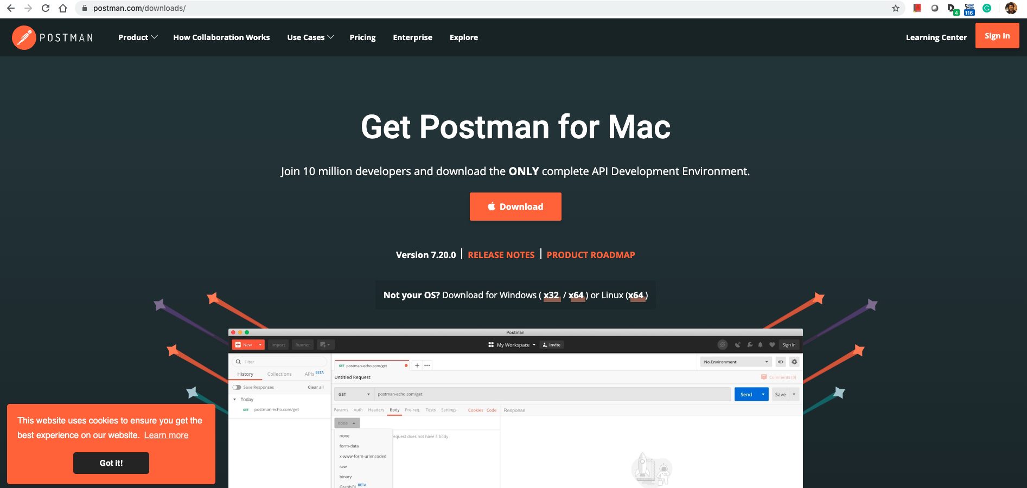

The file would be saved in your “downloads” folder, click on the file named “Postman-osx-7.20.0.zip” to extract the file

A postman app would be installed in your downloads folder as shown below, double click and launch the application



Note: If it asks to sign-in, please close that window, there is no need to sign-in. The main postman application window will be there in the background which you can continue to use.

**Step 2: Download postman collection files from box folder**

Open the following link (box folder), and download the entire folder to your “downloads” folder as shown below

<https://cisco.box.com/s/atzuzxzz0nsw4lqhu50ez7pwvm0vcpql>

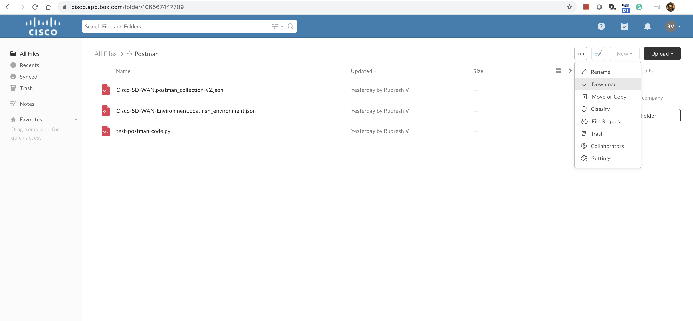

Extract the “Postman.zip” that was downloaded by double-clicking, so that you have the three files as shown below

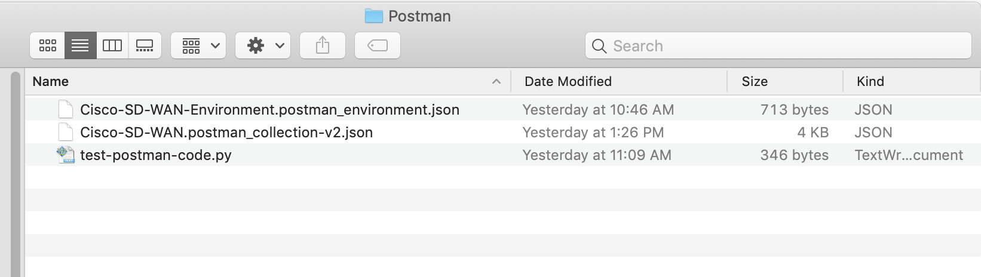

**Step 3: Import collection and environment files to postman**

Go back to the Postman application, and click on “Import” at the top left corner

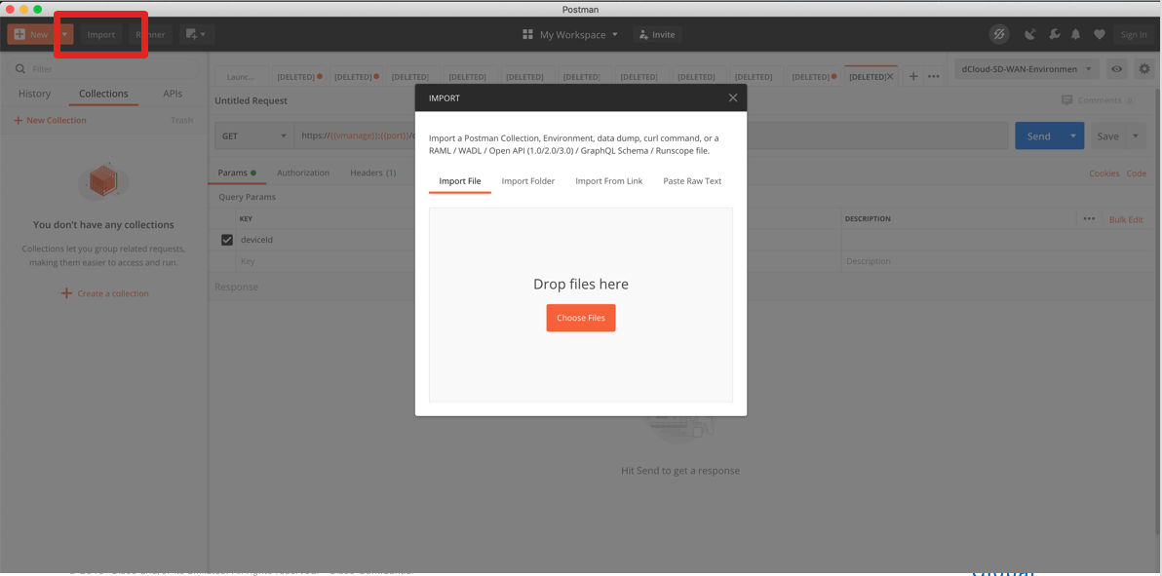

Select only the two files as shown in the screenshot below, and click on “open”

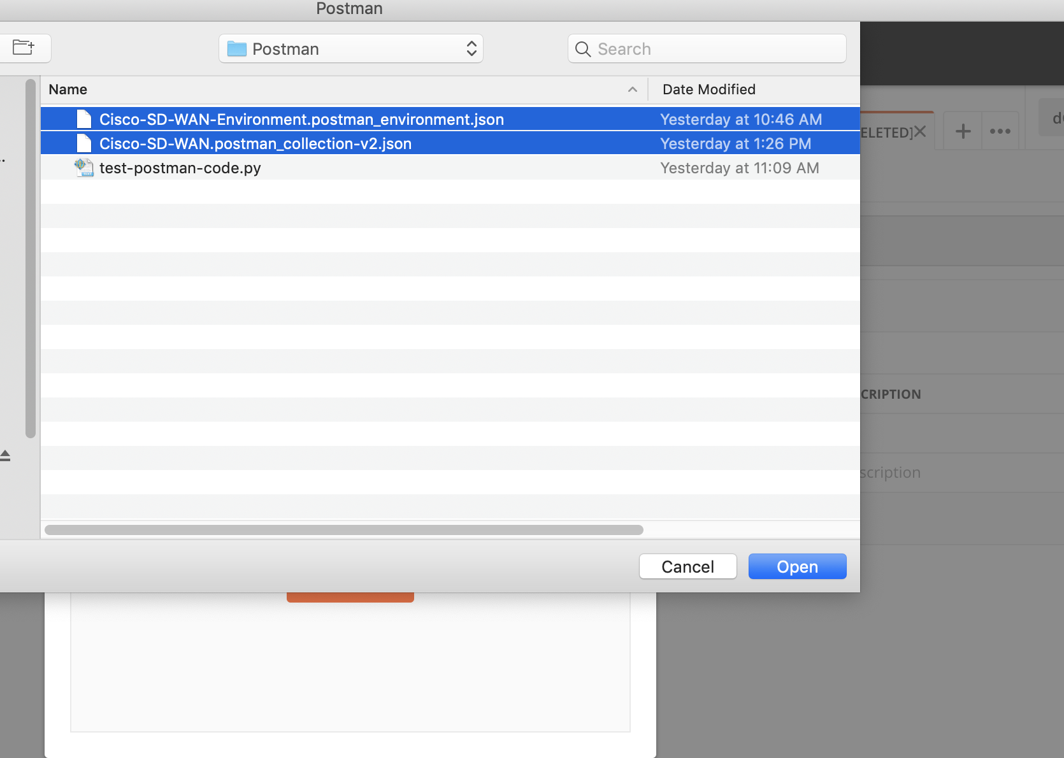

Now both the collections and environment variables would be loaded as shown below, verify the same:

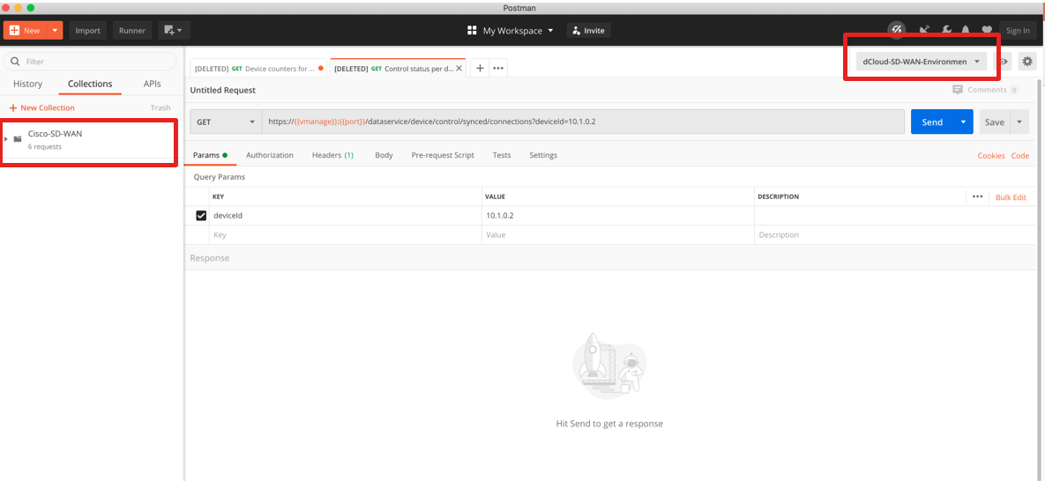

Click in the settings icon next to “dCloud-SD-WAN-Enviroment” at the top right corner as shown below, and confirm you have the following variables already loaded. These are the parameters we will be using for our APIs

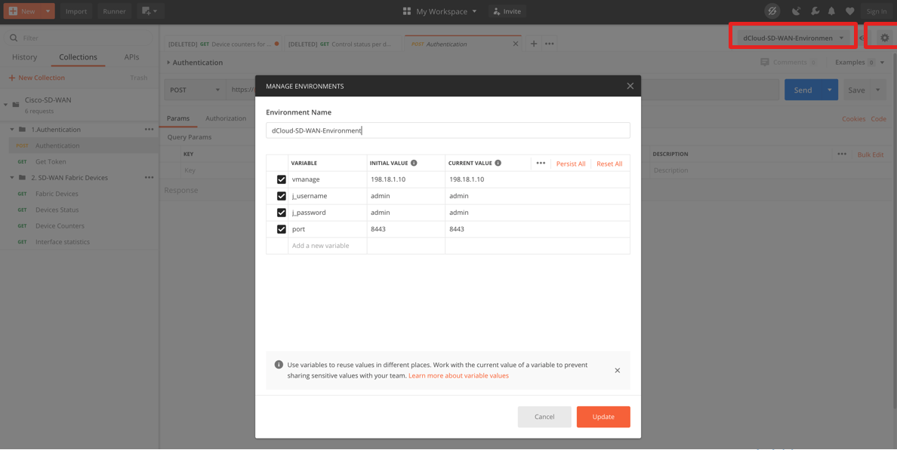

**Step 4: Disable SSL certification verification**

We need to disable SSL certification verification since the vManage in dCloud does not have a trusted certificate.

To do this, click on settings at the top right corner of the postman UI, and select settings.

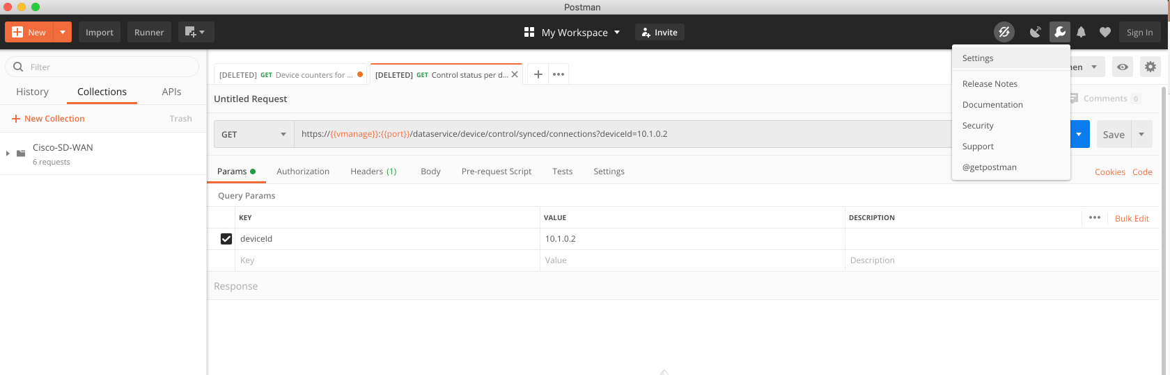

Next toggle the “SSL Certificate verification” to OFF as shown below

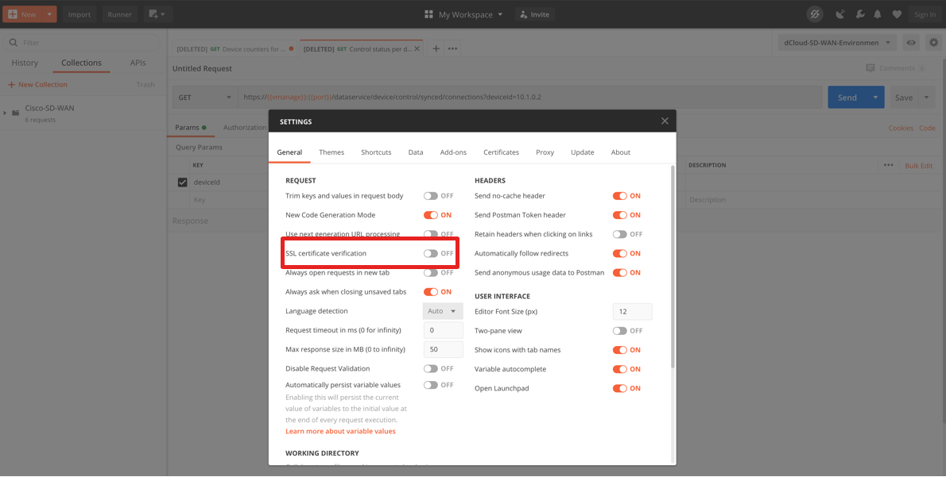

**Step 5: Use the examples in “Cisco SD-WAN” collections that we loaded**

Click on “Cisco SD-WAN” collections and further expand the “Authentication” and “SD-WAN Fabric devices” packages.

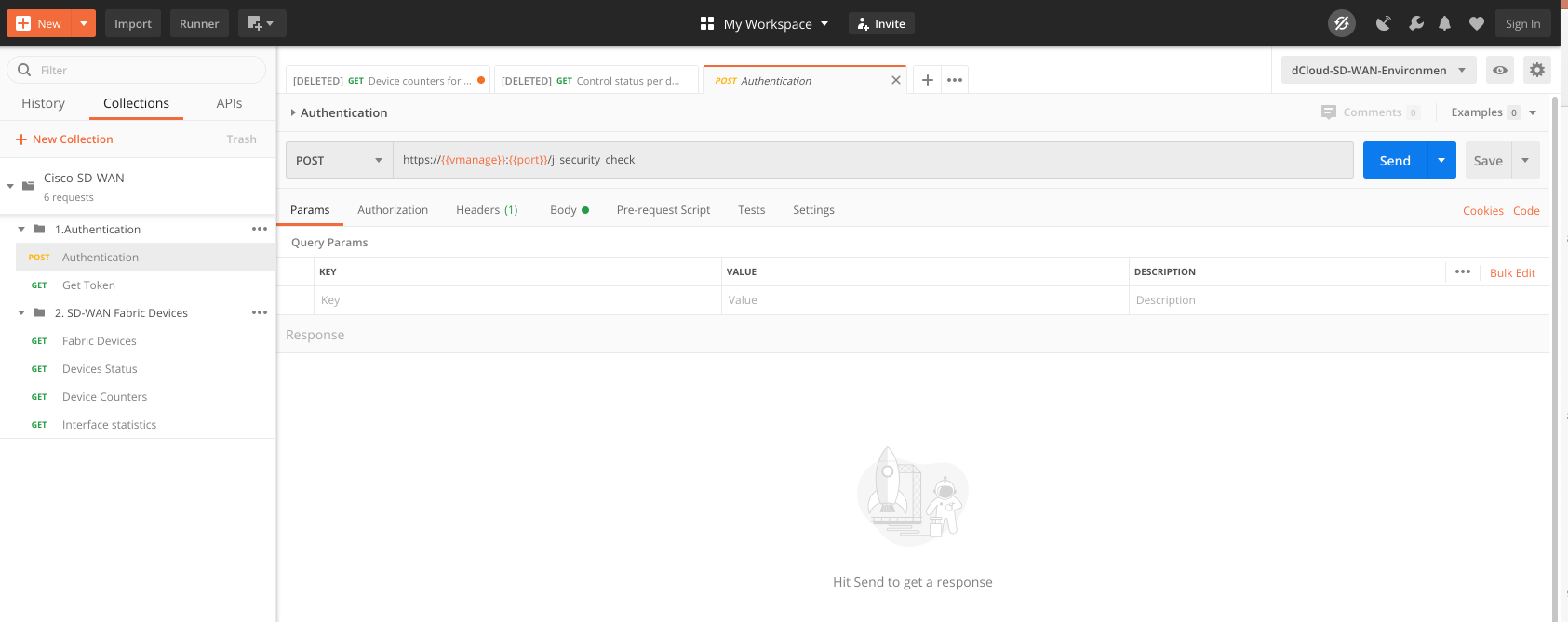

**Step 5.1:** **Authentication API**

Select the “Authentication” API from the list in the left tab as shown in the screenshot below, and then hit “Send”.

The response of “200 OK” means our login was successful. The Body would be empty which is expected.

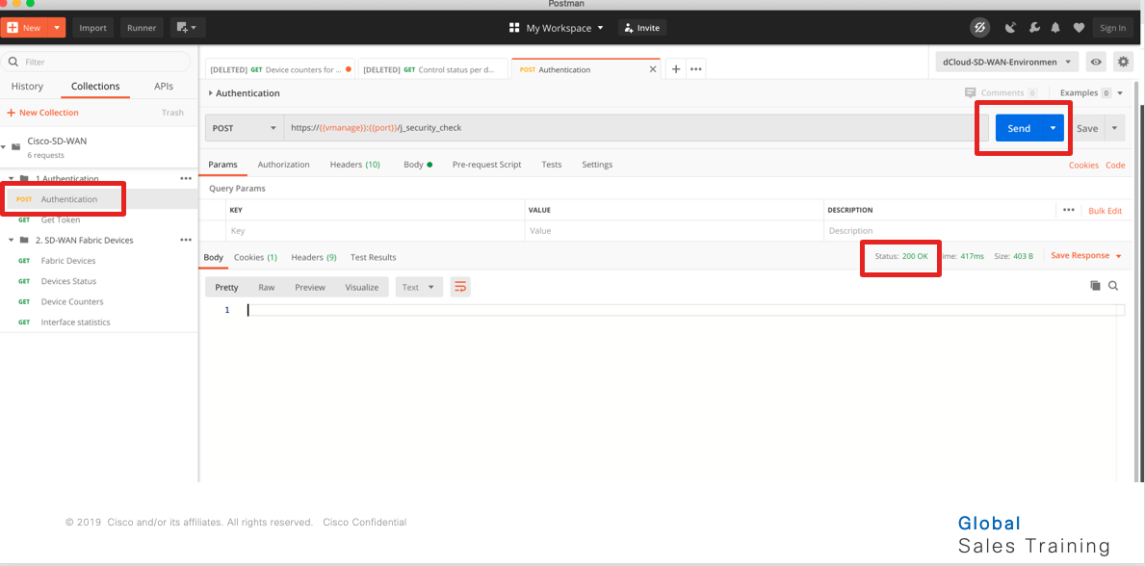

**Step 5.2: Get Token**

Next select the “Get Token” API from the list in the left tab, and hit send.

This will send an API request to get the Token for our session. If the query is successful, you will see the token in the body as shown below.

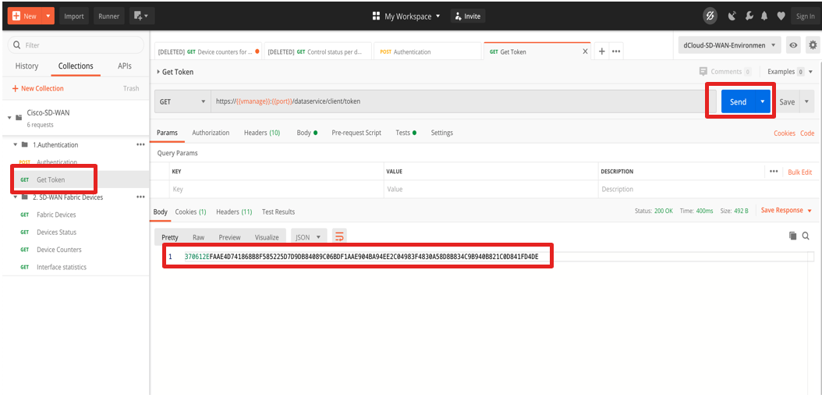

**Step 6.1: Send a GET request to get inventory of devices**

Click the first item under “2. SD-WAN Fabric Devices” which is called “Fabric Devices” which will load a GET as shown below to retrieve inventory of devices. Click Send

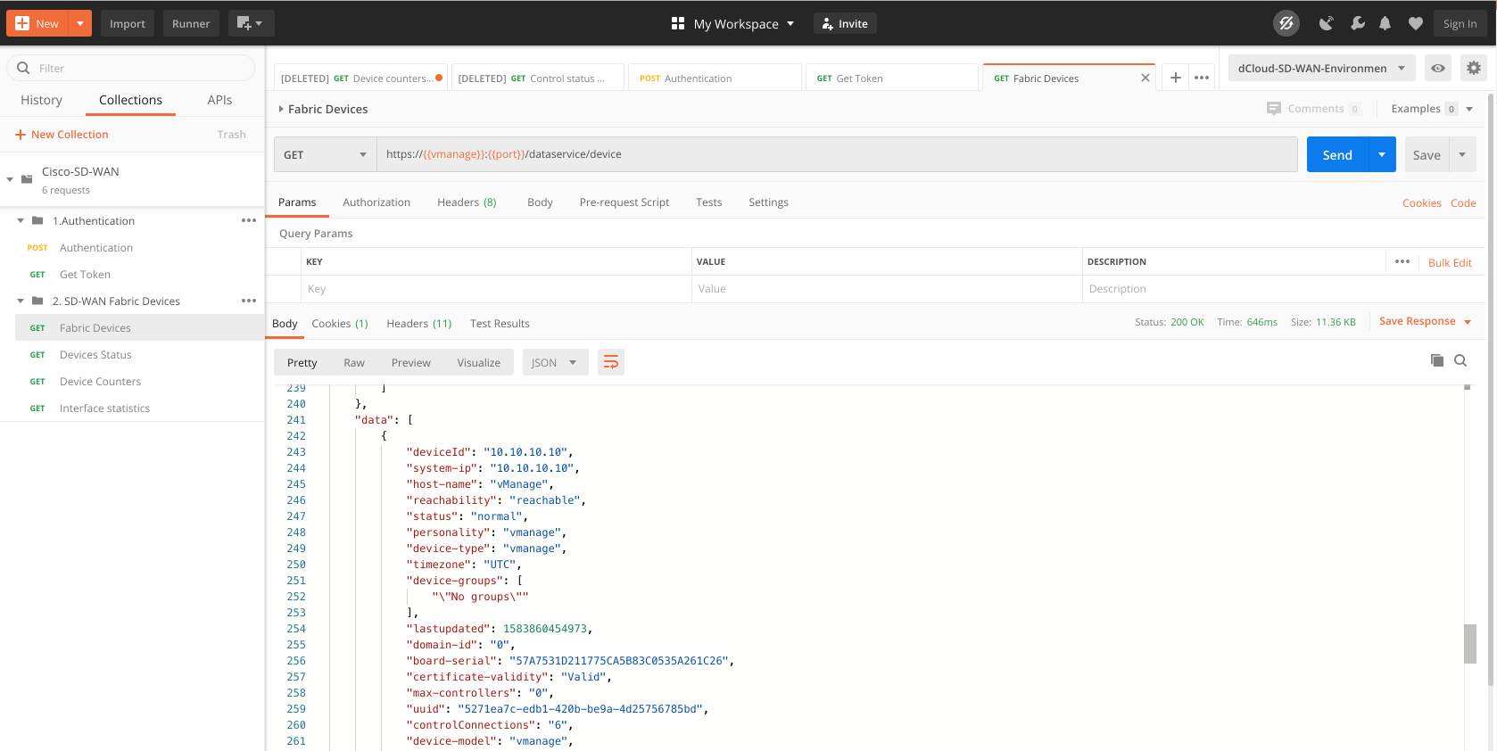

**Step 6.2: API to get Device Status**

Similar to the previous example, use the next item in the list called “Device Status” which will send a GET API call to retrieve status of all devices in the fabric

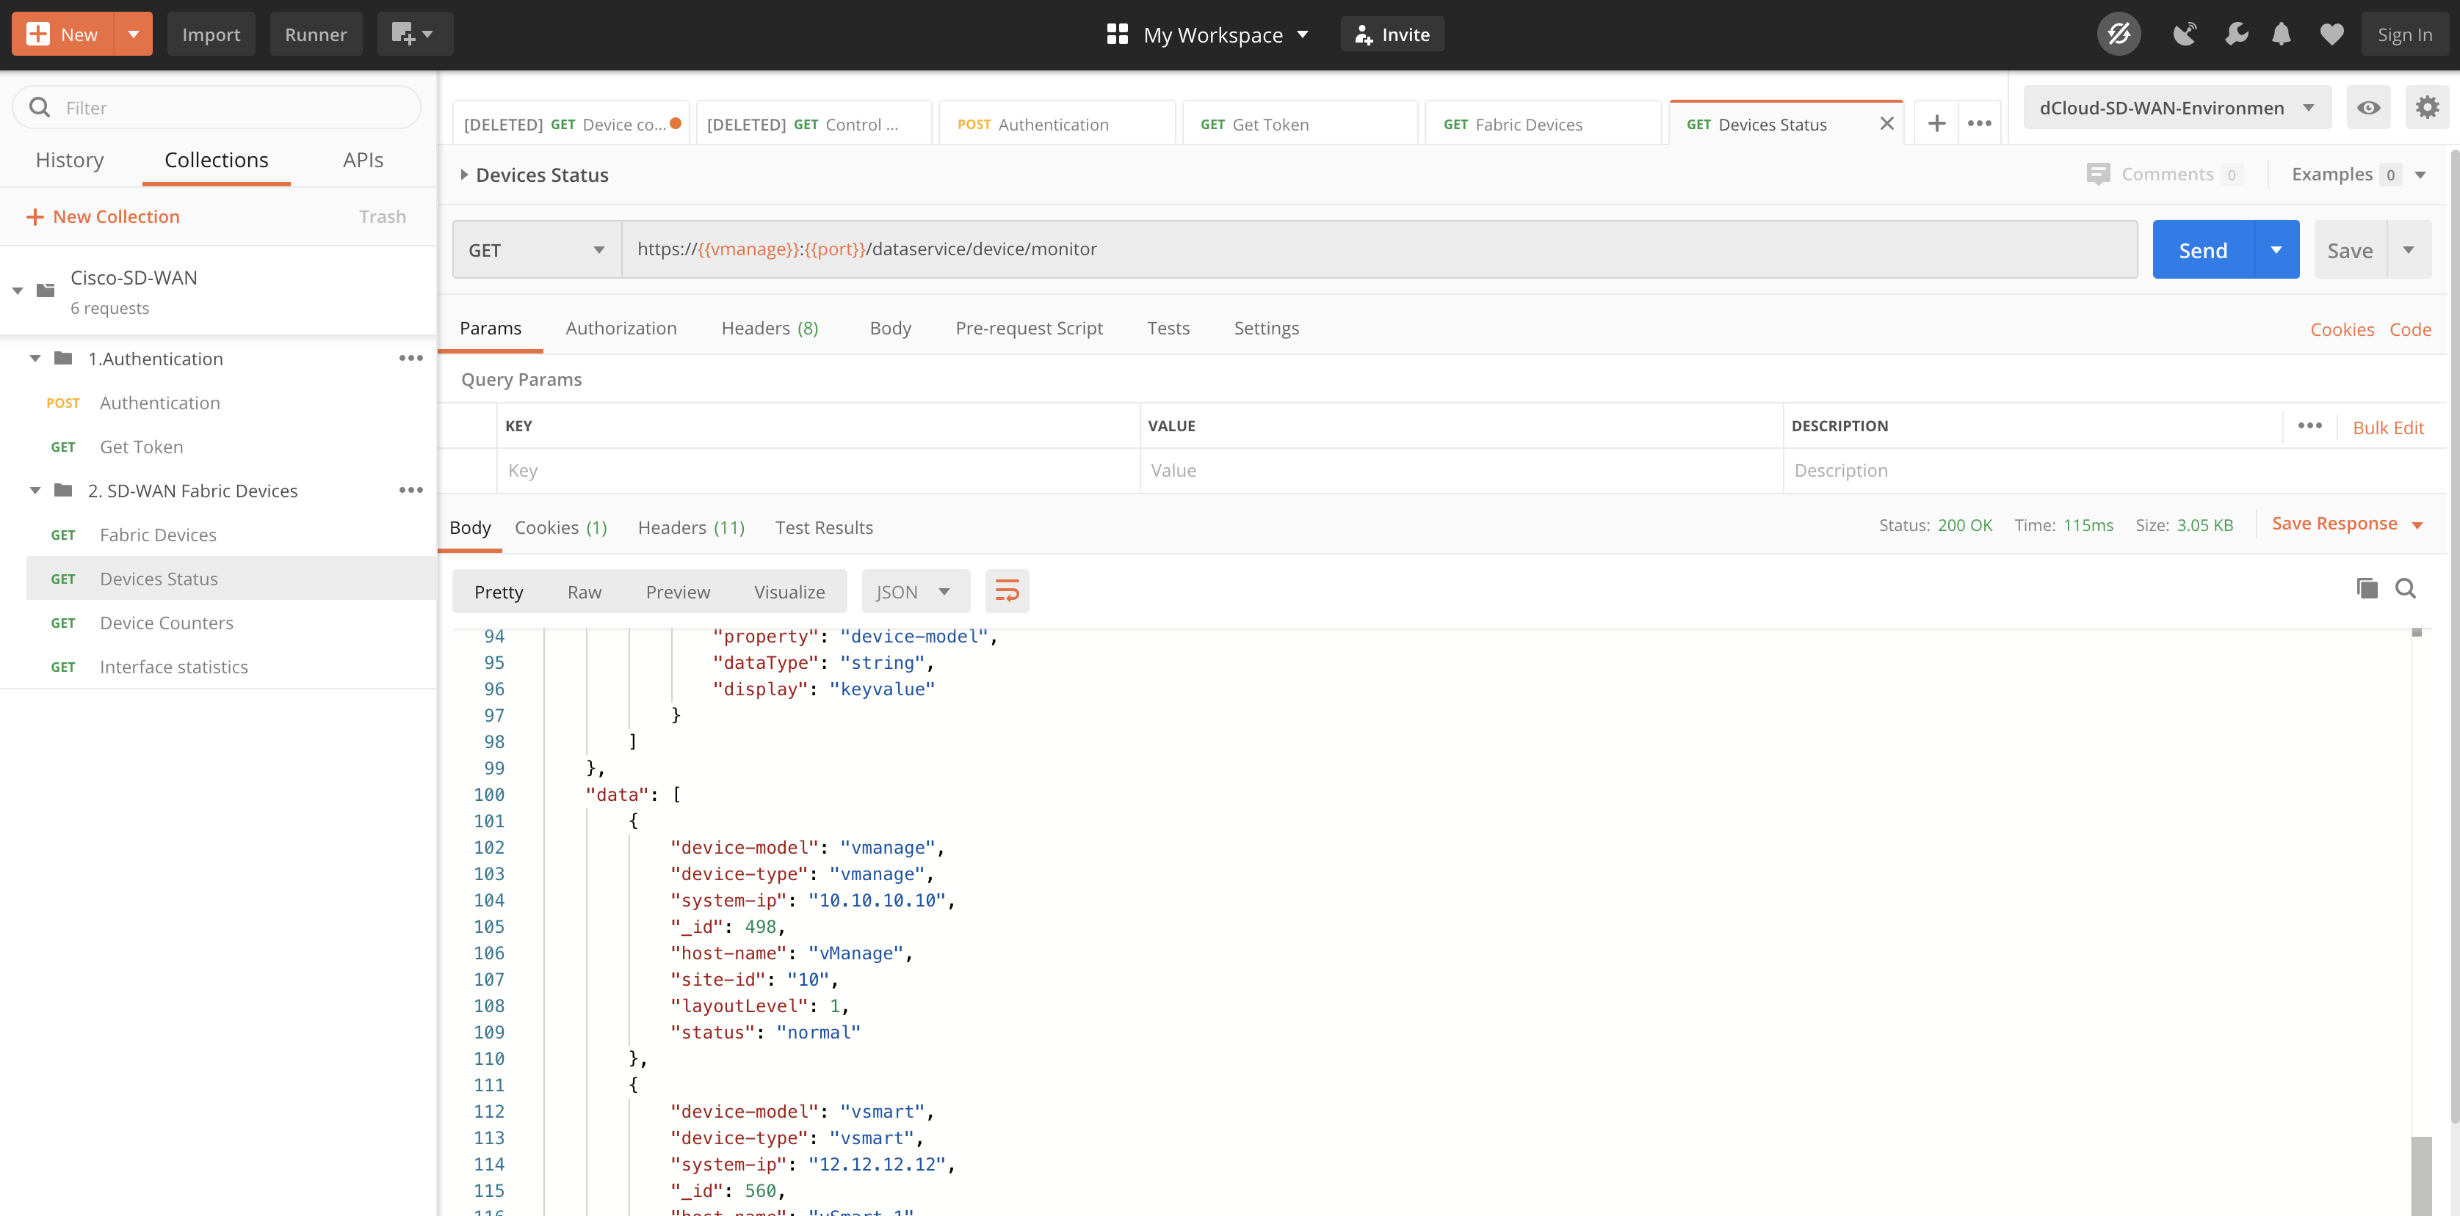

**Step 6.3: API call for Device counters**

Similar to the previous example, use the next item in the list called “Device Counters” which will send a GET API call to retrieve relevant counters of all devices in the fabric.

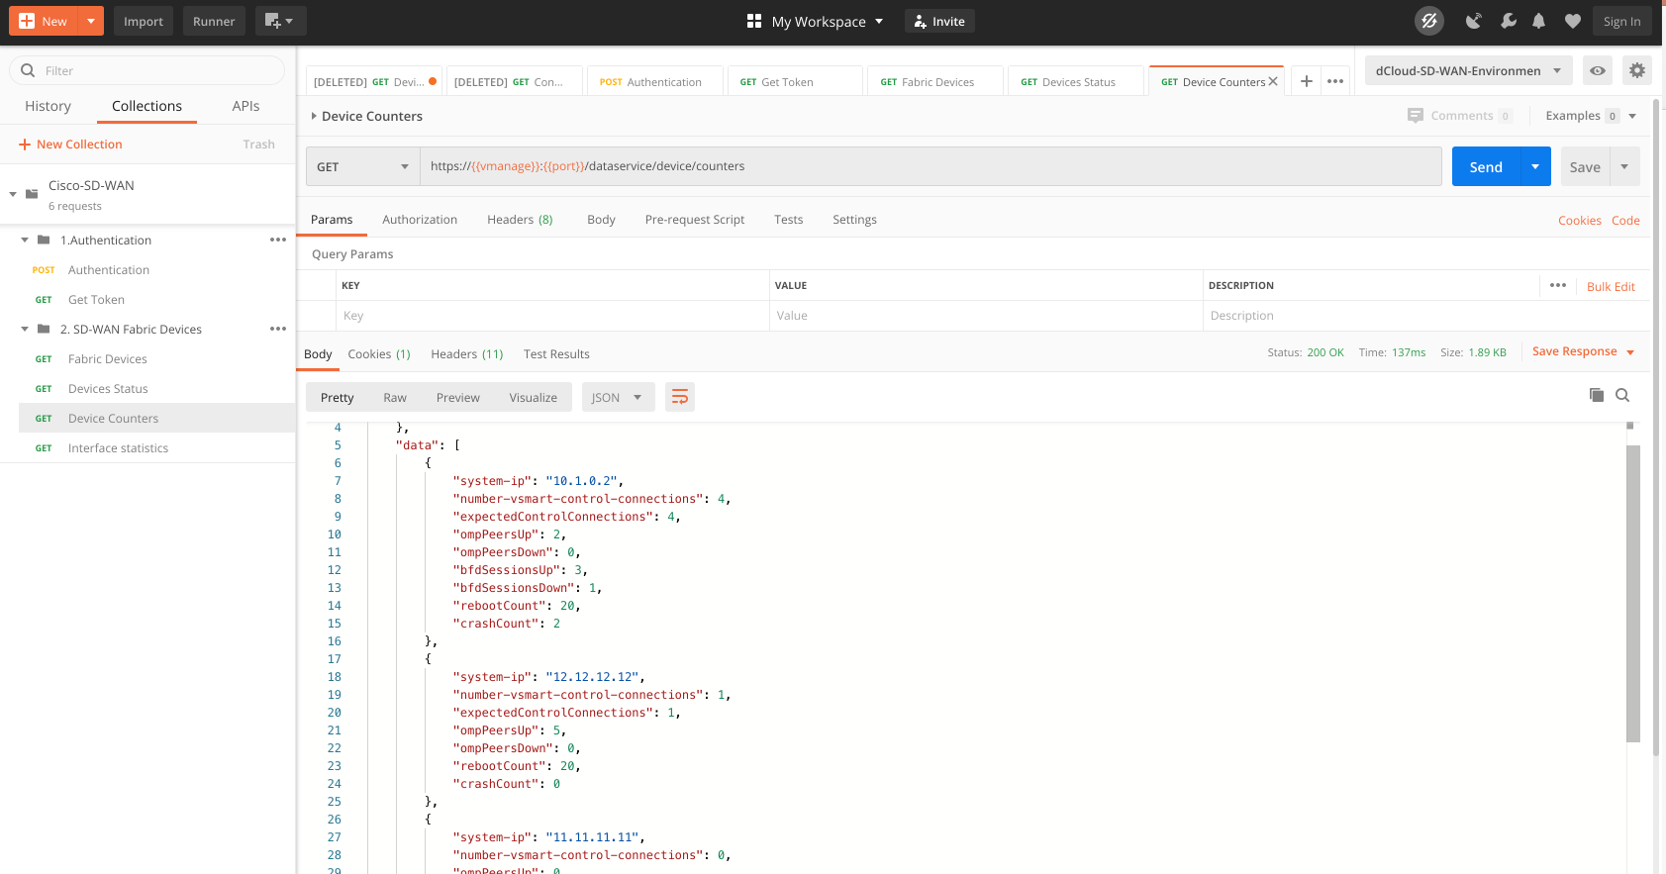

**Step 6.4: API call for Interface statistics**

Similar to the previous example, use the next item in the list called “Interface Statistics” which will send a GET API call to retrieve interface statistics of all devices in the fabric

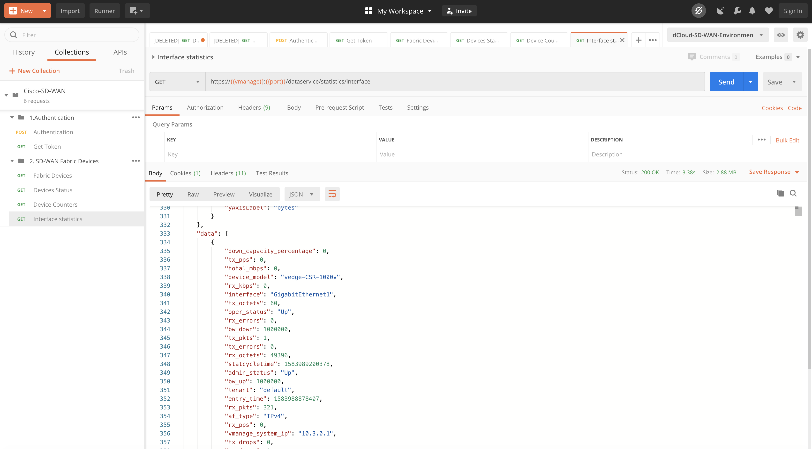

**Step 7:** **Create a new API Request**

To create a new API request, right click on the “2. SD-WAN Fabric Devices” section in the left tab as shown below, and click on “Add Request”

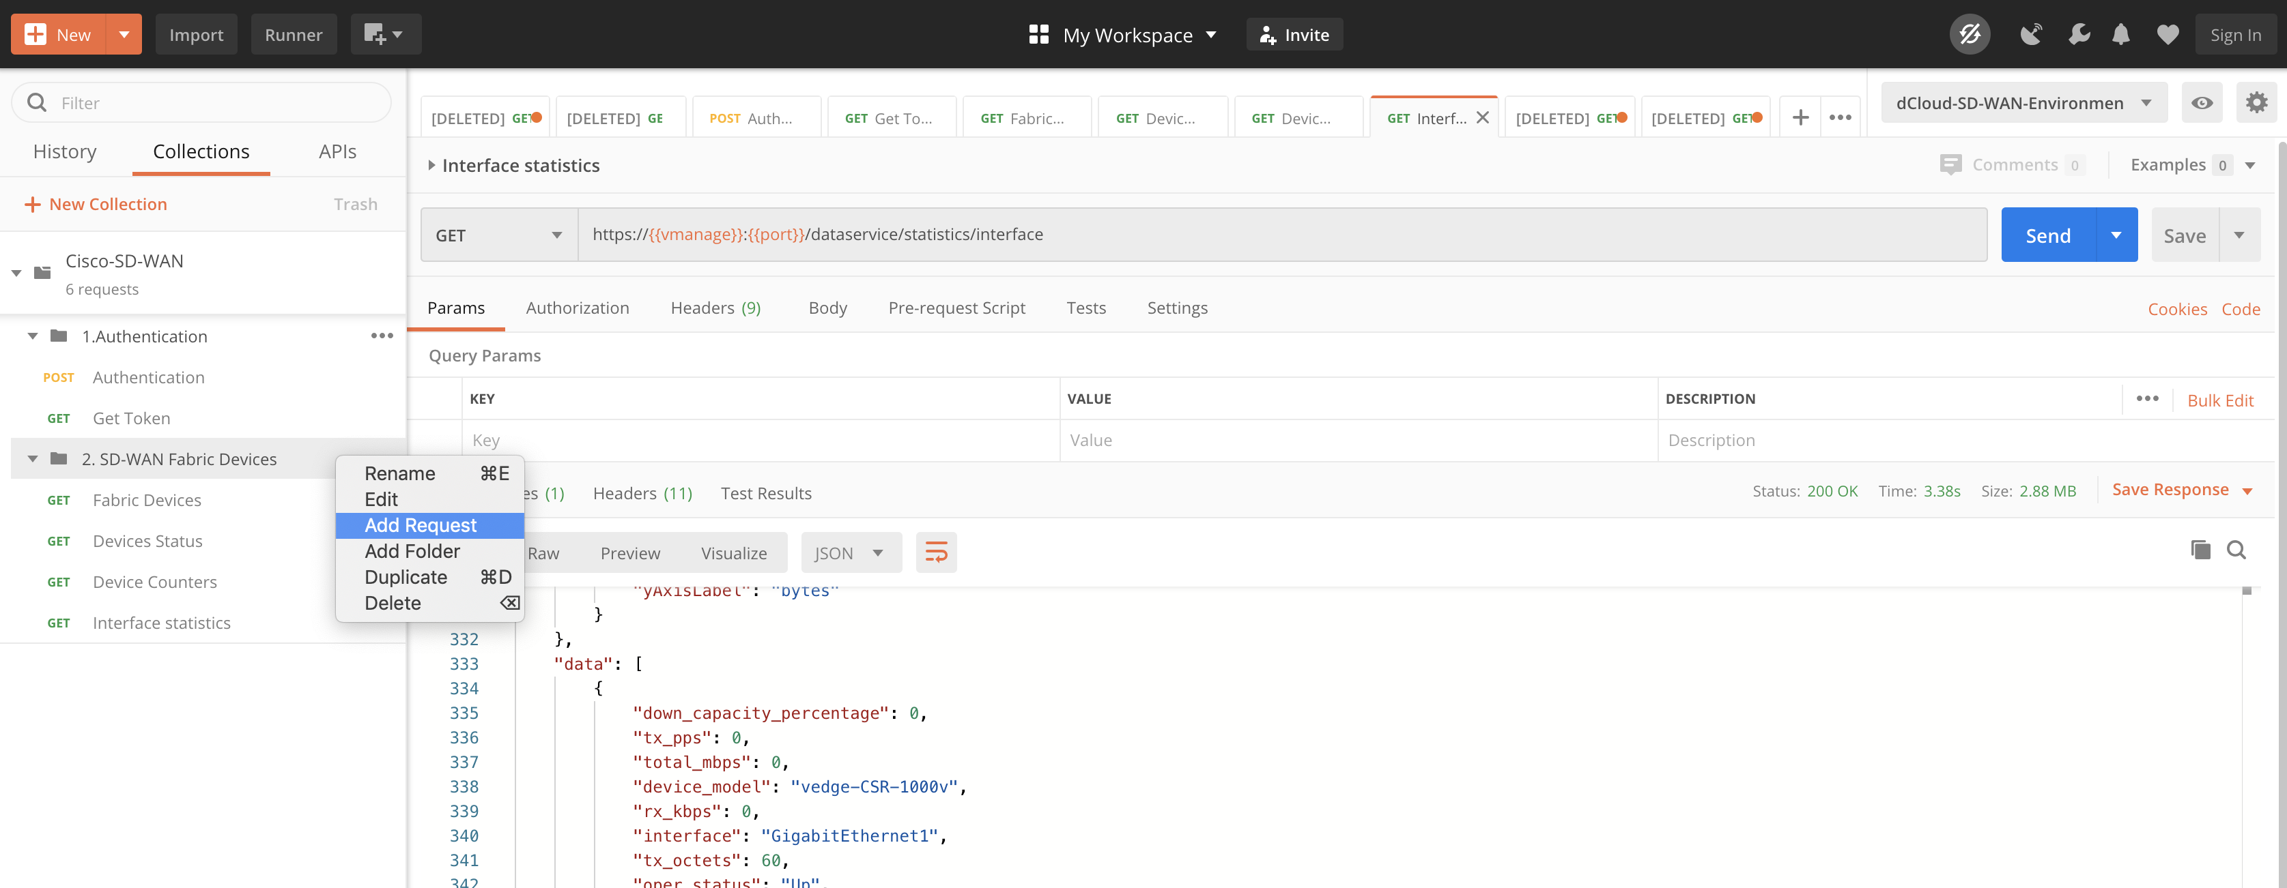

In the subsequent window, give the request a name like “Interface statistics per device” and hit save.

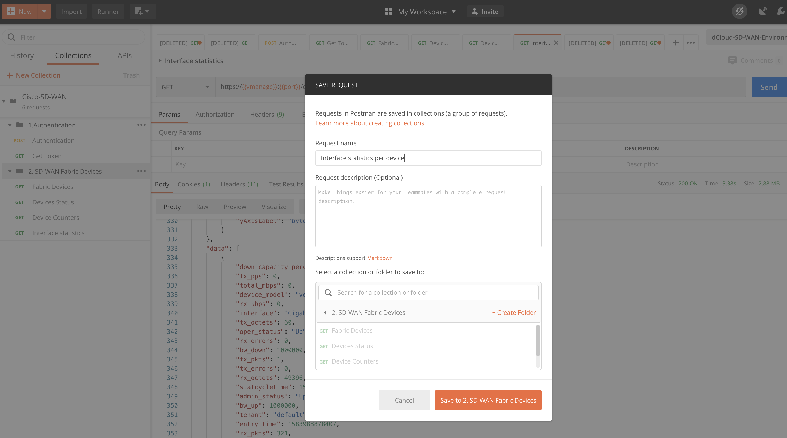

The new request is created, but is empty as shown below.

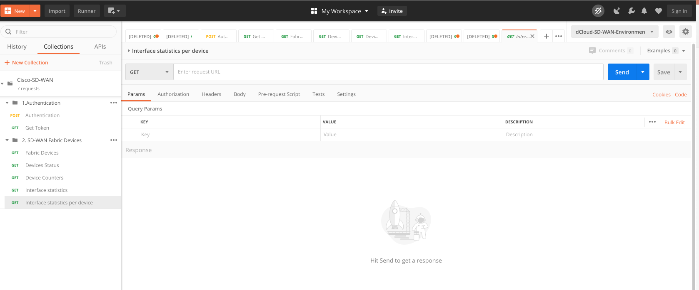

Next copy the following URI in the GET field as shown below:

https://{{vmanage}}:{{port}}/dataservice/device/counters/?deviceId=10.1.0.2

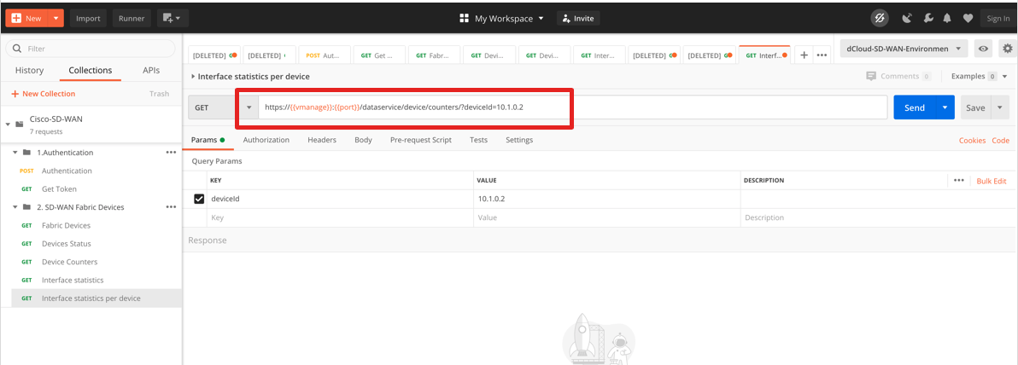

After this, click on “Headers” and add the token variable as shown below

KEY : X-XSRF-TOKEN

VALUE : {{X-XSRF-TOKEN}}

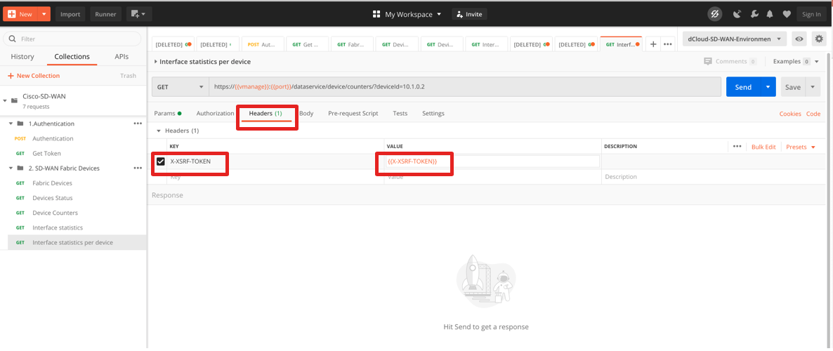

We are set with the new API request, click on “Send” and this will retrieve the device counters for the WAN edge 10.1.0.2, as shown below

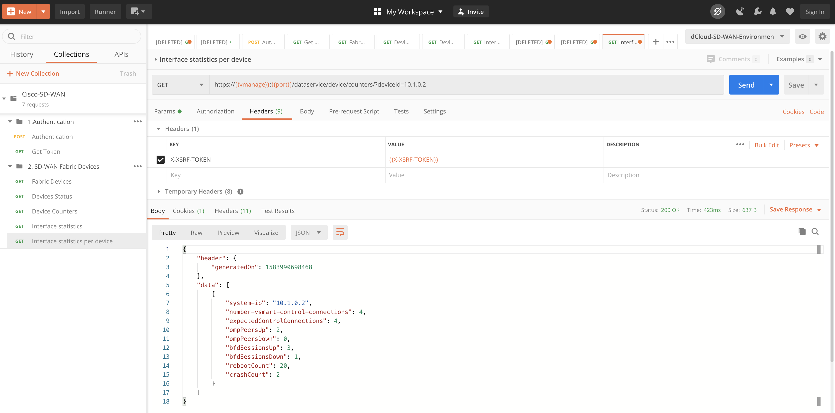

**#### End of Lab ####**

**For queries contact :** [**rudv@cisco.com**](mailto:rudv@cisco.com) **/** [**rlima@cisco.com**](mailto:rlima@cisco.com)